ASSIGNMENT–1

Type your text

NAME : Parthasarathi.S

COLLEGE:Sona College Of Technology

Create circuit with Piezoal arm,PIR sensor,tmp sensor with below functionalities:

1. Alarm should sound in one manner if temp is above 60C
2. Alarm should sound with another frequency if motion is detected in PIR sensor



ARDUINOUNOCODE

voidsetup()

{

Serial.begin(9600);pin Mode(2,INPUT);pinMo de(12,OUTPUT);

}

voidloop()

{

int

motion=digitalRead(2);if(motion= =1){Serial.println("Motion detected");tone(12,10);

delay(1000); noTone(12); delay(1000);

}

else{

Serial.println("Nomotion");

}

doubledata=analogRead(A2); doublen=data/1024; double volt=n*5;doubleoff =volt-0.5; double temperature=off*100;Serial.print( "Temperaturedata:");Serial.printl n(temperature);if(temperature>6

0.00)

{

tone(12,100); delay(500);n oTone(12);de lay(500);

}

}

OUTPUTS

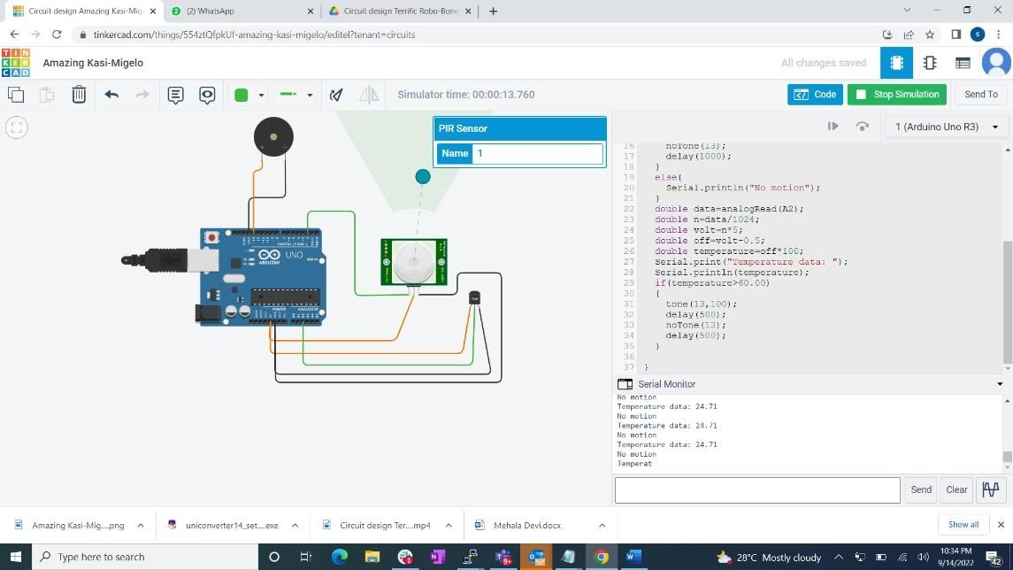

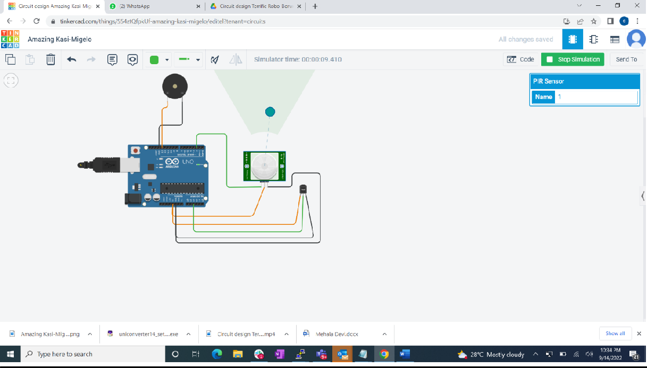

SIMULATION LINK:

[https://drive.google.com/file/d/1-](https://drive.google.com/file/d/1-G4uFywhLh2VL8yiIX0zeKD53URChPj_/view?usp=drivesdk)

[G4uFywhLh2VL8yiIX0zeKD53URChPj_/view?usp=drivesdk](https://drive.google.com/file/d/1-G4uFywhLh2VL8yiIX0zeKD53URChPj_/view?usp=drivesdk)